ITS 275 Project Report: Blackjack

Lauren A. LaRocca, Camden Levy, Tyler Patrick
Campbell University
ITS 275 Advanced Programming Language
Dr. Gilbert Munoz
4/12/2022

ITS 275 Project Report: Blackjack
The following is a brief project report in regard to the fulfillment of the ITS 275 final project requirements. The project itself is one round of Blackjack. The game begins with asking the user if they would like to play or read the rules. If they decide to read the rules, the rules will display for ten seconds, then the game will automatically begin. If the user decides to play or start, skipping the rules, the game will begin. Once the game begins, one of five dealers will be assigned to them. Similar to the game of blackjack, only one of the dealer’s cards are revealed. The user then receives two cards and can make the decision if they would like to stay, or receive another card (hit). Once the user decides to stay, the dealer’s second card is revealed. The user will then watch the dealer hit or stay. Both the dealer and the user have a four card max. When the dealer’s turn is over, the cards are added together and the program declares a winner.
Simplified Flow Chart
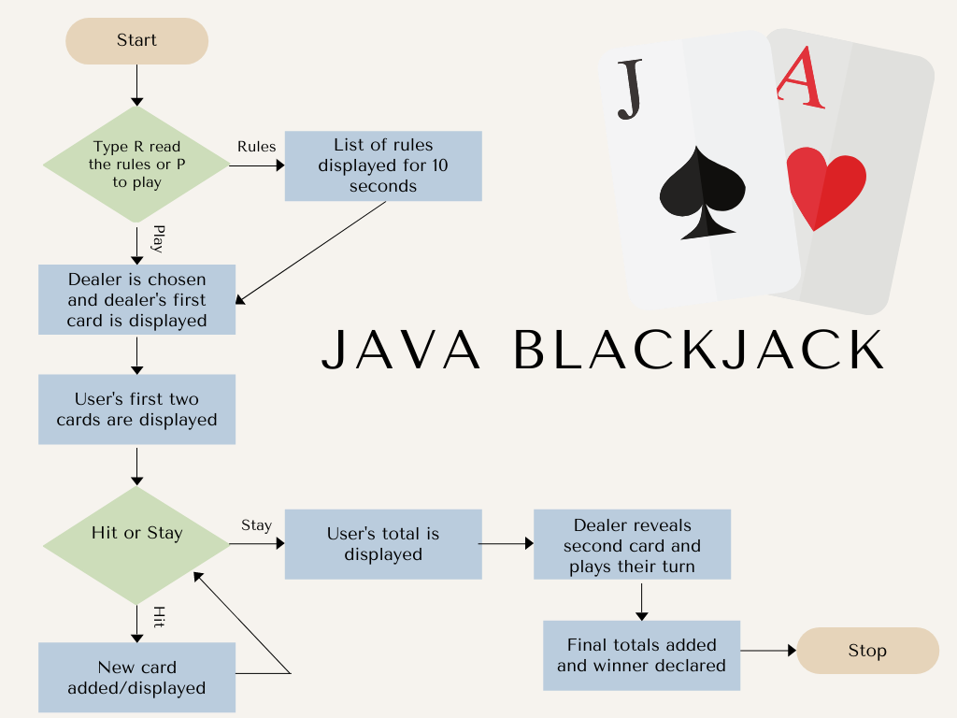

Method

Participants
For this project, Lauren LaRocca is the project manager, Camden Levy is the main developer, and Tyler Patrick is the secondary developer.

Problem Statement
Upon assessment of the midterm project, the team came to the conclusion that the project needed to be condensed and separated into separate classes. The original project consisted of around eight hundred lines of code, majority of which was the random generators. The program itself was organized and functioned correctly, however, code in the main game needed to be condensed. There are eight random generators, and each uses approximately fifty lines of code each. The team concluded that to improve this project, the code needed to become more elegant. The program could be complex, and allow for all the required elements, yet simple and easy to read.

Technical Approach
In order to accomplish all of the required elements for the final project, the code could not be limited to one large class. The game would need to be broken into five classes; MainGame, Randomgen, rules, formatting, and dealerArray. Each of these new classes would only be called when they were needed. This idea would aid in our goal for condensement. Reference the technical flow chart below for the processes.
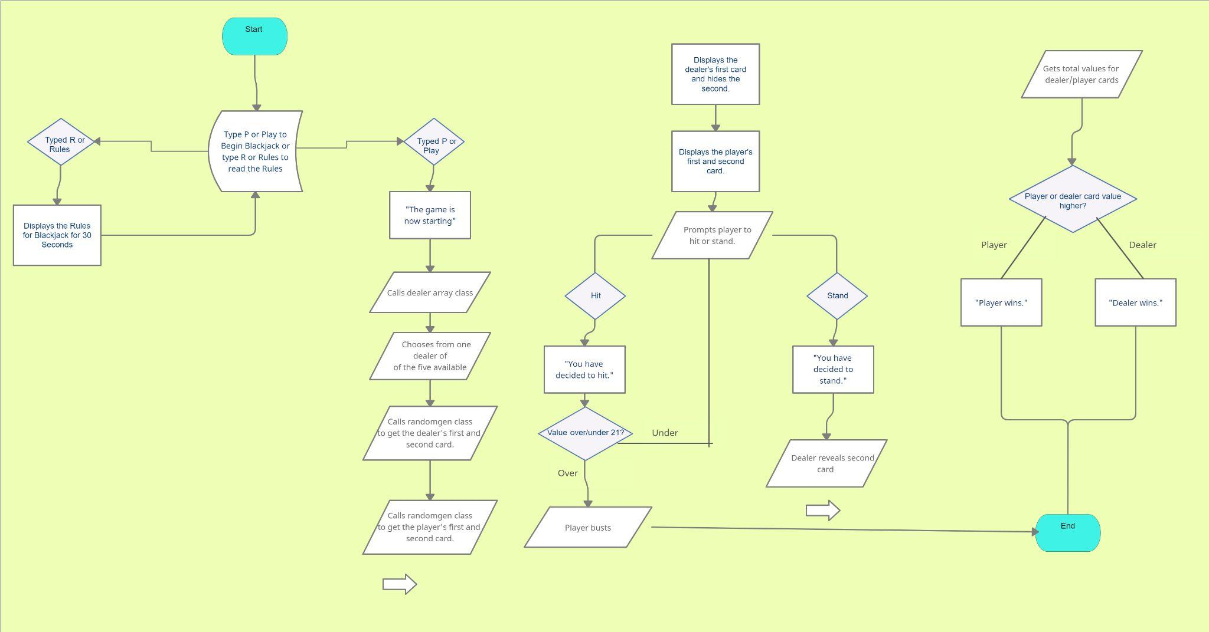

Software Design
The game was broken into five classes; MainGame, Randomgen, rules, formatting, and dealerArray. Please reference the bullet points below to read a description for each of the new classes.
- The randomed generators were taken out of the main class and put into their own class titled Randomgen. All eight generators are located in this class, and are able to be called in the MainGame class when needed. The generators themselves are the same from the original project, but were separated from the main game, located in class Randomgen.
- The rules to the program are optional, and are only called if the user calls them. They were also separated into their own class; rules.
- The formatting class allowed for the team to create a more aesthetically pleasing interface for the user. This class is called in between statements.
- The dealerArray class is called once the game begins. One dealer will be selected from a total of five dealers. Only one dealer is called per game.
- All main logic is in the MainGame class. This class is still relatively long, however, it is necessary with the amount of logic needed to run the game effectively
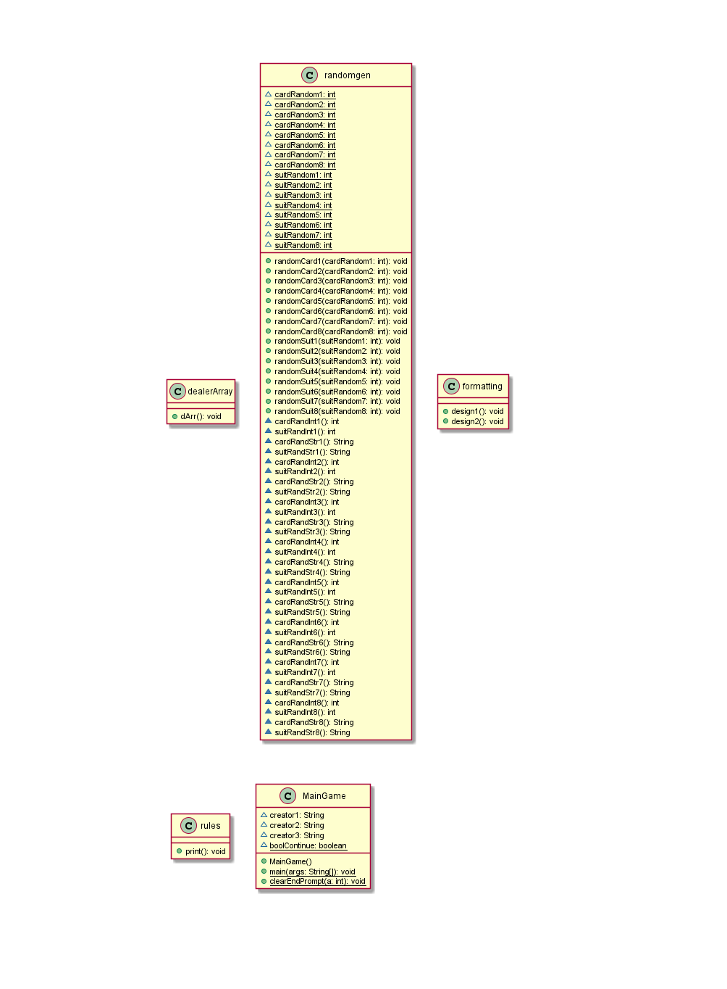
Please refer to the uml document below to reference the classes.

Results
The code successfully plays a single game of blackjack. The Game package contains one superclass (Maingame), and four subclasses. The superclass has the ability to call from all four subclasses. The rules will only be called if the user wants to read the rules. The user interface has also been improved, making for a more aesthetically pleasing, elegant game. Please refer to the screenshots below, each with a brief explanation of its functionality.

Outcome 1
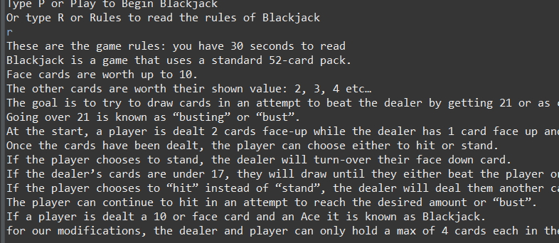
Game with the rules

Outcome 2
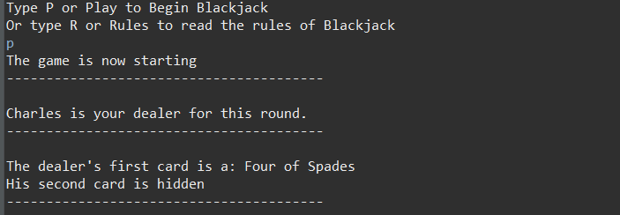
Dealer selection

Outcome 3
Hit or stand selection
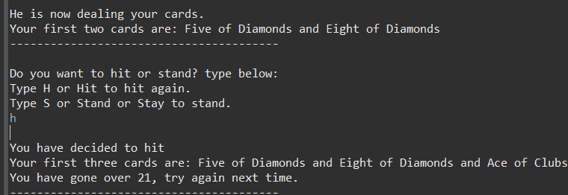
Outcome 4
A finished game
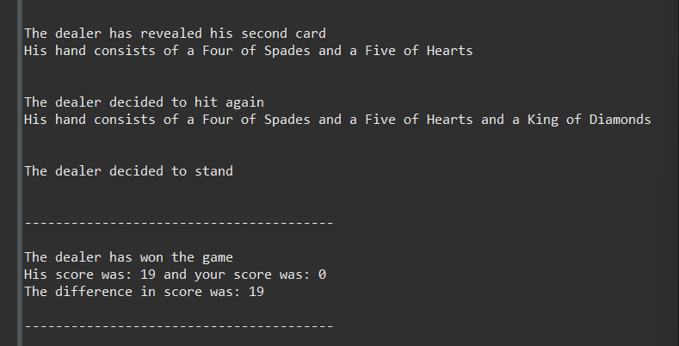

Discussion for Future Enhancements
If the team were to continue this project, a few additional elements and enhancements would be considered. Please refer to the bullet list below for those enhancement ideas
- One random generator
  - In the future, ideally there would be one complex random generator for the playing cards that would be called upon. Currently, the logic behind that is far past the current knowledge we have gained in this course
- User interface
  - In the future, improvements will be made to the user interface. To implement this, the team would incorporate an external software that would allow for pop-ups, such as swing. This way pictures of each card would be shown once they are drawn. There could also be pictures assigned to each of the dealers.
  - Instead of typing play, rules, hit, and stand, there would be buttons that the user could press.
- Play again option
  - Currently, the software only allows for one game to be played. In the future the team would ideally add a “play again?” option. This way the user would not have to restart the program in order to run another game.

